Lab 2: Ocean and Continents – Plate tectonics Due March 3th.
Follow the link to a reconstructed view of how Earth plates have moved in the past.
https://media.hhmi.org/biointeractive/earthviewer_web/earthviewer.html
Play the tutorial to learn how to manipulate the model (which is based on fossil, ocean, and rock analysis).
Move the globe so you can see New York. Then move the gauge backwards in time through the geological ages (see below). The scale is in millions of years (0 at top and 560 million at bottom).
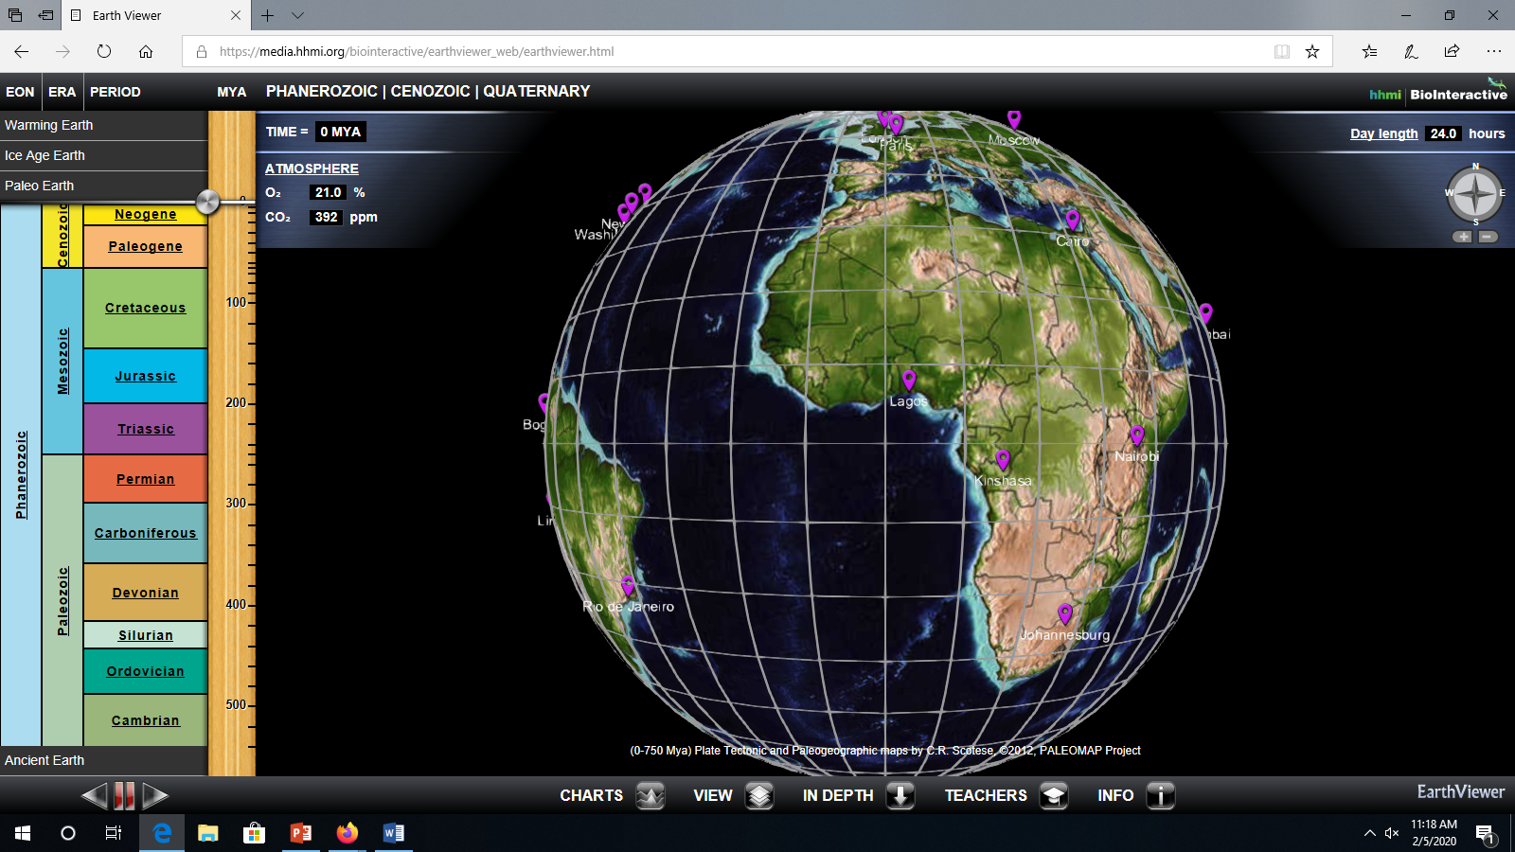
- As you move backward in time by slowly moving the time gauge down, how long ago were all the continents together? Triassic or Mesozoic Period

- Move all the way to the bottom. Move globe so you can see New York. Push the play button at the bottom of the screen.
- Pause often and readjust the model. Describe where New York city is through general areas (south pole, equator, north pole, etc.) of the globe at different times and if it is above or below water.
- Reset to about 400 million years ago. Describe the stages of the Willison Cycle that you see in the model for the Atlantic Ocean. Be specific in what is happening (what is moving and how many millions of years ago).
- Track Earth’s CO2 levels for every mark on the gauge (every 20 million years) and make a CO2 level vs years ago chart.
- Click on Ice Age Earth and center model on New York. Move gauge to 21,000 years ago. Move the gauge up by 1000 years each time, and note how the ice sheet changes in North America and Europe. What you think is happening to ocean levels during this time?
- Record and track CO2 levels during these changes and create a graph like in 2C.
- Why do the numbers go above zero? What does this mean for the north and south poles?
- Zoom in on Miami and go through the time sequence again. What happens to the size of Florida? Why does this happen?
Watch the Youtube Video about using Google Earth to look under the ocean.
https://www.youtube.com/watch?v=terD85scv4w
- While watching, note each location that is visited and create a list or chart with the following information for each visited location.
Location (what Ocean is it in)
Name (name of the feature)
Reason (what plate boundary or action is causing this feature)
Sediment (what type of ocean sediment do you think is being deposited at each location).

